**To:** Dr. Christopher Roberts and Dr. R Bertrum Diemer, Jr

**From:** Team T - Abdul Fayeed, Adarsh Kannan, Gavin Guerrera

**Date:** April 7th, 2022

**Subject:** Progress Report #2

**Abstract**

In the initial analysis, two different processes for the production of MeOAc were compared, with process flow diagrams detailing the recycles and separation structures shown. The esterification route would require one reactor and four distillation columns(to account for MeOH-MeOAc, and MeOAc-H2O azeotropes), while the carbonylation route would require one flash tank, two reactors, and three distillation columns. Furthermore, all the equipment for acetic acid needs to be made via stainless steel, as acetic acid corrodes carbon steel. From the level 0 economics, shown by the locus of critical investment values, it is clear that the carbonylation route is more feasible than the esterification route.

**Douglas’ First Method to Determine Batch vs Continuous**

This task was to determine whether the scaled up cumene process should be carried out via a batch or a continuous process. To determine this, the Douglas method was utilized. For processes whose annual production is less than 500 tons/yr, the batch process is preferred. On the other hand, if the production is greater than 5,000 tons/yr, the continuous process is preferred. As shown in **Appendix A**, the required production of methyl acetate is 170,097 tons/yr, which is greater than 5,000 tons/yr, hence determining that the continuous process is preferred in this scenario.

**Assumptions for Esterification** The esterification process assumed a 100% yield (i.e. no side reactions) during conversion, and to achieve this, a recycle stream was utilized. A high per pass conversion rate of 100% was also assumed. Since there are two binary azeotropes present, four distillation columns will be used to separate this. The reactor is run at a temperature of 90oC, due to the temperature limitation specified in the prompt, and due to the increase in the rate of reaction as a function of temperature.

**Assumptions for Carbonylation**

The assumptions made for the carbonylation process were that the initial dehydration of methanol would achieve a 90% per pass conversion. Furthermore, the side reaction was also analyzed in the carbonylation step, with both the main and side reaction achieving a per pass conversion of 90%. The separation structure for the distillation consisted of two fired heaters to increase pressure to aid separation. There are two distillation columns present, to separate the MeOH-DME-H2O ternary. The temperature and pressure conditions for the separation structure were optimized using the ASPEN software. The separation structure for the carbonylation step consisted of a flash tank to separate the CO, H2 and CH4, and another distillation column to recover the MeOAc produced.

**Input-Output Structure**

The flow diagram for the Carbonylation process can be seen below in **Figure 1**. The diagram begins with a fresh feed of 99.9 % methanol with the remainder being water. The feed, along with the 1st recycle, goes through the dehydration reactor. The temperature of the reactor was chosen at 390oC because this is near the degradation temperature of the catalyst and allows for better kinetics. After the reactor, the DME, Methanol, Water mixture was run through the first distillation column where the DME was distilled with 99% purity. The bottoms of the column containing the water and methanol were run through another distillation column where the distillate was recycled containing mostly methanol while the bottoms were purged. The DME mixture was combined with a fresh feed of 99.5% carbon monoxide to the carbonylation reactor. The same catalyst was used allowing for another reactor with ~390oC. It is important to note that the reactor was fed with an excess of carbon monoxide due to its lower cost. The reactor outlet contained the methyl acetate product as well as carbon monoxide and small amounts of DME, methane, and methanol. Due to the very low boiling point of carbon monoxide, a distillation column could not be used immediately after the reactor, instead a flash tank was used. The carbon monoxide as well as amounts of methyl acetate and small amounts of methanol, methane, and hydrogen. The considerable amount of methyl acetate in the recycle is inefficient and will be resolved once the process is optimized. This steam was also compressed to ~ 12 bar to match the feed pressure given. The remaining liquid from the bottom of the flash tank contained the methyl acetate product as well as small amounts of methanol, DME, and carbon monoxide. This stream was then fed to a final distillation column where a 99.9% purity of methyl acetate left the bottom while the remaining DME, methanol, and CO was distilled and purged. The purge is also within the required ppm limits given in the write up.

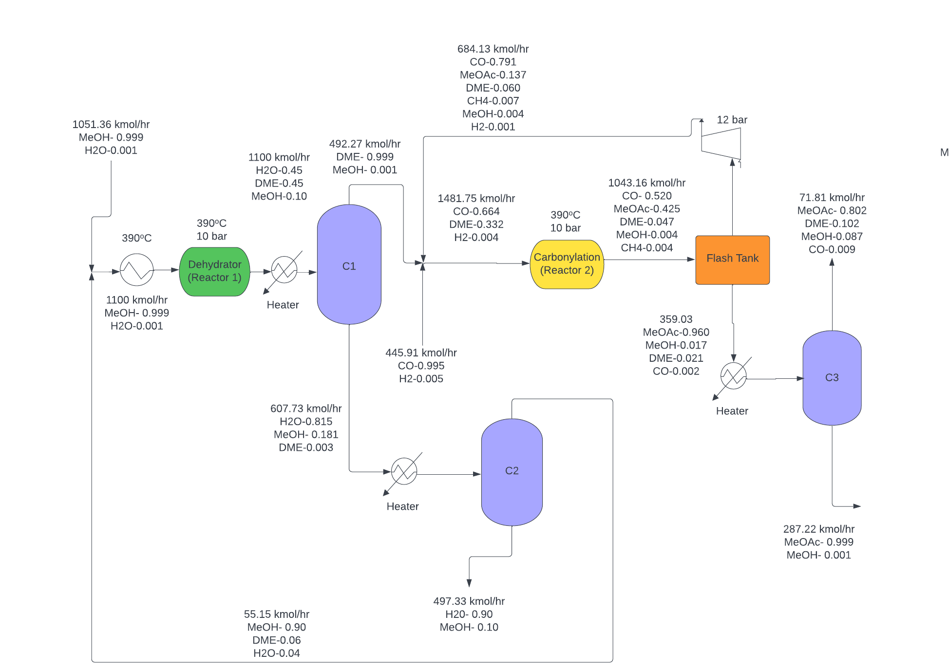

**Figure 1.** Carbonylation Process Flow Diagram H-Mordenite Catalyst

The flow diagram for the Carbonylation process can be seen below in **Figure 2.** The diagram begins with a fresh feed of pure methanol and acetic acid. The feed, along with the 1st recycle, goes through the dehydration reactor. The temperature of the reactor was chosen at 100oC because this is the optimal temperature accounting for catalyst limitation and kinetics. A heat exchanger is used to heat the fresh feed and recycle to the optimal reactor temperature. After the reactor, there is a stream consisting of MeOAc,MeOH, acetic acid and water. Here, there is an issue in separation of MeOAc-MeOH, which forms a minimum boiling azeotrope at 68% mol of MeOAc. Thus, two distillation columns are required for the separation of this azeotrope.The first distillation column separates most of the acetic acid and water back into the reactor from the bottom, with MeOH,MeOAc and H2O being the products present in the distillate. The second distillation column is utilized to separate water from MeOH and MeOAc. The third and fourth distillation columns are run at elevated pressures in order to break the MeOH-MeOAc binary azeotrope.

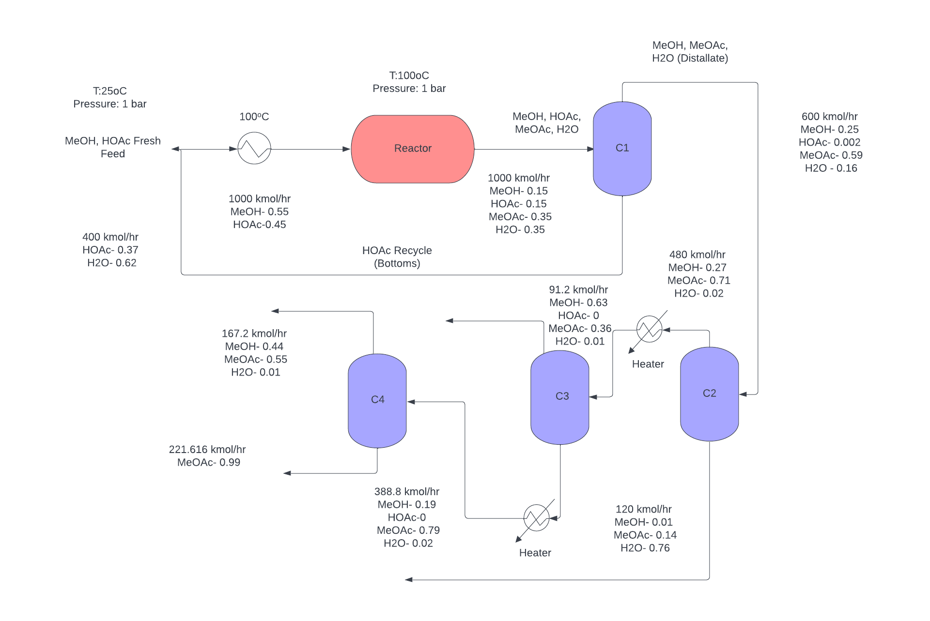  
**Figure 2.** Esterification Process Flow Diagram

**BOE Material Sizing**

The back of the envelope (BOE) method was utilized to size all units present in the process to produce methyl acetate (MeOAc). For the carbonylation route, the process is divided into two parts, the dehydration of methanol to produce dimethyl ether (DME), and the carbonylation of DME with carbon monoxide to produce MeOAc.

For the first part of the carbonylation process, two distillation columns with two reboilers and condensers, and two fired heaters were used. The second part of the process meanwhile utilizes one distillation column with one condenser and reboiler, a flash tank, a compressor, and a fired heater.

Reboilers and condensers were sized by assuming they were heat exchangers. **Appendix A** shows how to find the heat-exchange area by utilizing the heat duty and design flux in the exchanger. On top of that, the flash tank is sized by acquiring a diameter and height of the column, as shown in detail in **Appendix B**. Moreover, the sizing method for a distillation column is done with the number of stages priorly determined. For a fired heater, the sizing method is similar to a heat exchanger, where the heat duty is used to size. Lastly, the compressor is sized based on its consumed power to run the process.

**Cost Analysis**

To determine the cost related to heat exchangers, it was essential to ascertain the type of heat exchanger required for the process. Thus, the change in inlet temperature, $ΔT_{in}$ was used as a measure. For < 50oC, the fixed heat heat exchanger was utilized, while for > 50oC, the floating head heat exchanger was utilized. Based on the areas calculated in sizing in **Appendix A**, the bare-module cost of the heat exchangers can be computed as shown in **Appendix C**.

To cost the distillation column, the diameters were first scaled based on the flow rates, and this is done as shown in **Appendix D**. To cost the flash tank, the diameter and length of the tank were found priorly as shown in **Appendix B**. **Appendix D** shows the detailed calculations to cost a distillation column and vertical pressure vessel (flash tank). Furthermore, **Appendix E** and **F** show how to cost a compressor and fired heaters respectively.

**Preliminary transfer price, NPC and NROI**

**Table 1** provides the investment estimate (VGA), cost of manufacture (COM), net present cost (NPC), net return of investment (NROI), and transfer price for both carbonylation and esterification processes. From the table, it is clear to note that while the VGA and NPC are lower with a slightly higher COM and higher NROI for esterification process, the Transfer Price at 25% NROI and IRR for esterification is significantly higher than the value for carbonylation. Even so one were to operate esterification over carbonylation solely because esterification has greater NROI and looks profitable in the long run, one has to consider the competing route from a competitor with a transfer price of $1,520/tonne of MeOAc from a recovery of dimethyl acetate (DMAc). Instead of choosing to operate the esterification process, consumers are better off to purchase the product from the competitor. This clearly indicates that the carbonylation route has higher feasibility potential than the esterification route and is beneficial on our end.

**Table 1.** Comparison of VGA, COM, NPC, NROI, and transfer price of two processes.

| **Route** | Carbonylation | Esterification |
| --- | --- | --- |
| **VGA ($MM/yr)** | 25 | 11 |
| **COM ($MM/yr)** | 215 | 285 |
| **Transfer Price @ 25% NROI ($/tonnes)** | **1,454** | **1,903** |
| **Transfer Price @ 25% IRR ($/tonnes)** | **1,490** | **2,420** |
| **Actual NROI (%)** | 32 | 126 |
| **Revenue @ 350MMppy MeOAc ($MM/yr)** | 253 | 411 |
| **NPC ($MM/yr)** | -5 | -88 |

**Conclusions**

From the NROI, NPC, transfer price, and locus of critical investment curve, it is clear that carbonylation is a more viable option for the synthesis of MeOAc than the esterification process. Primarily, due to the high price of acetic acid, the fixed investment at which esterification can compete with carbonylation is $500 million. Furthermore, side reactions were assumed for the carbonylation process, whereas no side reactions were assumed for esterification. This was to compare the ‘best case’ scenario for esterification with a non-optimal case for carbonylation. Thus, the carbonylation process could be optimized further to give better estimates for fixed investment costs, and consequently NROI, whereas the esterification process would become worse once the competing reaction is modeled. Moreover, the transfer price of MeOAc sales with the esterification method is higher by $1000 than that for carbonylation, further indicating the deviation between the two. Finally, the recycle structure for the dehydration step in carbonylation was not ideally optimized, which increases chances of improving this further in order to reduce variable costs.

**Limitations**

One main limitation in the process models considered is that there are no side reactions in the esterification route. Moreover, the recycle structure for the dehydration step in the carbonylation process is non-ideal, and requires further optimization. Finally, the material balances done so far were crude, and would be difficult to replicate.

**Future Work** Now that the carbonylation route has been selected as the better option for manufacture of MeOAc, the next step is to determine the ideal catalyst for the dehydration step, along with an apt recycle design. The isothermal plug flow reactor needs to be compared with an adiabatic reactor. Finally, further optimization of the recycle stream and separation structure, with final design, NPC, NROI and transfer price listing is required to finalize the decision, and move further with energy analysis.

**Appendices**

***Appendix A: Determination of Heat Exchange Area***

**Table A.** Various values of heat flux

| **Type of flux** | **Flux value (BTU/hr/ft2)** |
| --- | --- |
| Gas-to-gas | 300 |
| Liquid-to-liquid | 8,000 |
| Phase change | 10,000 |
| Condensing steam | 12,000 |

To find a heat exchange area, the type of flux has to be determined first in order to use the appropriate heat flux value. Assume that it is a gas-to-gas flux with a heat transfer duty of *a* BTU/hr. The heat exchange area is determined as shown in **Eq. A**.

$Heat exchange area,A=\frac{a BTU/hr}{300 BTU/hr/ft^{2}}=\frac{a}{300}ft^{2}$**Eq. A**

***Appendix B: Determining the Length and Diameter of the Flash Tank***

To find the length and diameter of the flash tank, the flow rate into the tank has to be determined first. Let’s use an arbitrary number of 1,043.16 kmol/hr as the inflow rate. This flow rate is converted to m3/hr by considering the molar composition and density of the components in the inflow.

**Table B1.** Molar composition and thermodynamics properties for each component

| **Components, i** | **Molar composition, xi** | **Molar mass, MWi (g/mol)** | **Density, ρi (g/m3)** |
| --- | --- | --- | --- |
| Methanol | 0.0043 | 32.04 | 792,000 |
| Dimethyl ether | 0.0472 | 46.07 | 2,110 |
| Water | 0.0000 | 18.02 | 997,000 |
| Carbon monoxide | 0.5191 | 28.00 | 1,140 |
| Methyl acetate | 0.4247 | 74.08 | 932,000 |
| Hydrogen | 0.0005 | 2.00 | 84 |
| Methane | 0.0043 | 16.00 | 657 |

The flow rate in kmol/hr can be converted to m3/hr by using **Eq. B1**.

$Flow rate (m^{3}/hr)=\frac{\sum_{i}^{n}{}x_{i}MW_{i}}{\sum_{i}^{n}{}x_{i}ρ_{i}}$**Eq. B1**

From the volumetric flow rate, since flash tanks can be assumed to have 5 minutes residence for half tank (10 minutes for full tank), the total volume of tank can be calculated as **Eq. B2**.

$Volume (m^{3})=Flow rate (m^{3}/hr)×10 mins×1/60 (hr/mins)$**Eq. B2**

To find the length of the tank, it is assumed to have a cylindrical shape. From the volume formula in **Eq. B3**, the diameter can be found from L/D = 2.5 relationship as priorly assumed. **Table B2** shows the length and diameter computed.

$V=π{(\frac{D}{2})}^{2}L$**Eq. B3**

**Table B2.** Diameter and Length for flash tank.

| **Parameter** | **Values (ft)** |
| --- | --- |
| Diameter | 7.23 |
| Length | 18.08 |

***Appendix C: Computing the Purchase Cost of Heat Exchanger***

The purchase cost of a heat exchanger can be calculated by using **Eq. C1**.

$C_{P}=F_{P}×F_{M}×F_{L}×C_{B}$**Eq. C1**

To solve **Eq. C1**, **Eq. C2** and **C3** have to be computed first.

$F_{P}=0.9803+0.018\left(\frac{P}{100}\right)+0.0017{\left(\frac{P}{100}\right)}^{2}$**Eq. C2**

$F_{M}=a+{\left(\frac{A}{100}\right)}^{b}$**Eq. C3**

**Table C1.** Values of FL

| **Tube length (ft)** | **FL** |
| --- | --- |
| 8 | 1.25 |
| 12 | 1.12 |
| 16 | 1.05 |
| 20 | 1.00 |

It is assumed that the tube length is more than 20 ft, thus FL is 1.00 from **Table C1**. To find FM, since the exchangers are made of carbon steel, the values of a and b are equal to 0, making FM to be 1.00. To solve for CB, **Eq. C4** and **C5** are used for floating- and fixed-head heat exchangers respectively.

$C_{B}=exp[12.031-0.8709 ln A+0.09005 (ln A)^{2}]$**Eq. C4 $C_{B}=exp[11.4185-0.9228 ln A+0.09861 (ln A)^{2}]$** **Eq. C5**

Finally, to find CBM, **Eq. C6** is used. **Table C2** summarizes the notations used in all equations.

$C_{BM}=F_{BM}×C_{P}$**Eq. C6**

**Table C2.** Notation used in heat exchangers cost determination

| **Notation** | **Definition** | **Unit** |
| --- | --- | --- |
| CP | Purchase cost | $ |
| FP | Pressure factor | - |
| FM | Material factor | - |
| FL | Tube length factor | - |
| CB | Base cost | $ |
| A | Heat exchange area | ft2 |
| P | Pressure | psi |
| a | FM factor | - |
| b | FM factor | - |
| CBM | Bare-module cost | $ |
| FBM | Bare-module factor | - |

***Appendix D: Computing the Purchase Cost of Distillation Column/Vertical Pressure Vessel***

The purchase cost of a distillation column or vertical pressure vessel can be calculated by using **Eq. D1**.

$C_{P}=F_{M}×C_{V}+C_{PL}+C_{T}$**Eq. D1**

To solve **Eq. D1**, **Eq. D2 - D7** have to be computed first.

$C_{PL}=341(D_{i})^{0.63316}(L )^{0.80161}$**Eq. D2**

$C_{T}=N_{T}×F_{NT}×F_{TT}×F_{TM}×C_{BT}$**Eq. D3**

$F_{NT}=\frac{2.25}{1.0414^{N_{T}}}$**Eq. D4**

$C_{BT}=468 exp(0.1482×D_{i})$**Eq. D5**

$C_{V}=exp\{7.139+0.18255 ln W+0.02297(ln W)^{2}\}$**Eq. D6**

$W=ρt_{s}π(D_{i}+t_{s})(L+0.8D_{i})$**Eq. D7**

$t_{p}=\frac{P_{d}D_{i}}{2SE-1.2P_{d}}$**Eq. D8**

Finally, to find CBM, Eq. G6 is used. **Table D** summarizes the notations used in all equations.

$C_{BM}=F_{BM}×C_{P}$**Eq. D9**

**Table D.** Notation used in distillation column/vertical pressure vessel cost determination

| **Notation** | **Definition** | **Unit** |
| --- | --- | --- |
| CP | Purchase cost | $ |
| FM | Material factor | - |
| CV | Empty vessel cost | $ |
| CPL | Platform/ladder cost | $ |
| CT | Tray cost | $ |
| NT | Number of trays | - |
| FNT | Tray number factor | - |
| FTT | Tray type factor | - |
| FTM | Tray material factor | - |
| CBT | Base tray cost | $ |
| Di | Inner diameter | ft |
| L | Length | ft |
| W | Vessel weight | lb |
| ρ | Metal density | lb/ft3 |
| ts | Shell thickness | ft |
| CBM | Bare-module cost | $ |
| FBM | Bare-module factor | - |

***Appendix E: Computing the Purchase Cost of Fired Heater***

To size the fired heater, **Eq. E1** is used to solve for its base cost for a heat duty Q range of 10 ≤ Q ≤ 500 MM BTU/hr. The purchase cost is computed by using **Eq. E2**.

$C_{B}=exp\left[-0.15241+0.785ln\left(Q\right)\right]$**Eq. E1**

$C_{P}=F_{P}F_{M}C_{B}$**Eq. E2**

The pressure factor FP is calculated from **Eq. E3**, with a pressure P range of 500 ≤ P ≤ 3,000 psig.

$F_{P}=0.986-0.0035\left(\frac{P}{500}\right)+0.0175{\left(\frac{P}{500}\right)}^{2}$**Eq. E3**

Again, engineering assumptions have to be made in terms of choosing the materials for fired heaters to be economically feasible and safe to operate. The material factor FM is as listed in Table z.

**Table E1.** Values of FM for different type of heater materials

| **Type of materials** | **Values of FM** |
| --- | --- |
| Cr-Mo alloy | 1.4 |
| Stainless steel | 1.7 |

Lastly, the bare-module cost can be computed from **Eq. E4** with FBM values of between 1.86 (field-fabricated fired heaters) and 2.19 (shop-fabricated fired heaters).

$C_{BM}=F_{BM}C_{P}$**Eq. E4**